

Cardiff Metropolitan University

Cardiff School of Technology

BSc Software Engineering

Addressing the Shortage of Chemistry Teachers and Laboratory Facilities for Higher Education Students in Rural Sri Lanka.

Submitted in [Month]

2025

By

Jayawardhana Mudiyanselage Navod Thishan Vishvajith Jayathilake.

(Student ID – st20258180 – KD/BSCSD/18/17ICBT ID)

This dissertation is submitted in partial fulfillment of the requirements for the degree of

Bachelor of Science in Software Engineering (BSc SE)

##### DECLARATION

This work is being submitted in partial fulfillment of the requirements for the degree of

…………………………………………………………………………………………. and has not previously been accepted in substance for any degree and is not being concurrently submitted in candidature for any degree.

Signed - ............................................................ (Candidate) Date - ...................................

##### SUPERVISOR’S DECLARATION STATEMENT

Student Name – Supervisor’s Name -

I acknowledge that the above named student has regularly attended the meeting, and actively engaged in the dissertation supervision process.

Signed - ……………………………………………. (Supervisor) Date - …………………......

# Acknowledgement

# Abstract

Rural Sri Lanka faces significant challenges in providing quality science education to higher education students, particularly in Advanced Level (A/L) studies. Key barriers include a shortage of qualified chemistry teachers and inadequate laboratory facilities, restricting students’ opportunities to acquire critical scientific knowledge and practical skills. This paper explores a targeted strategy to address these issues by implementing teacher training programs and integrating virtual laboratory technologies into the education system. The proposed interventions aim to enhance teaching quality, promote interactive learning, and provide students with hands-on experiences, even in resource-limited environments. This initiative seeks to bridge the educational gap between rural and urban regions by fostering critical thinking, creativity, and problem-solving abilities, enabling students to achieve academic success and better career prospects in science-related fields.

Table of Contents

Acknowledgement 3

Abstract 4

Introduction 6

Current situation leading to problem identification 7

Proposed Technique to Solve the Current Problem 9

Another 11

Background Studies 11

Problem Statement 11

Objective 12

Solutions 12

Literature Review 14

# Introduction

Science education in rural Sri Lanka is hindered by significant barriers, including a shortage of qualified chemistry teachers and the absence of adequate laboratory facilities. Chemistry, as a cornerstone of science education, plays a pivotal role in shaping students’ understanding of the natural world and equipping them with skills essential for academic and career growth. However, students in these under-resourced regions face limited access to quality education, which impacts their ability to explore the subject deeply and develop critical scientific competencies.

The shortage of trained chemistry teachers in rural areas has created a reliance on educators with limited expertise, further widening the educational gap. Compounding this issue is the lack of functional chemistry laboratories, which denies students the opportunity to engage in essential hands-on experiments. This gap between theory and practice inhibits the development of analytical thinking, creativity, and problem-solving skills necessary for students to thrive in higher education and future careers in STEM fields.

This project proposes a multifaceted approach to overcome these challenges by focusing on two key solutions: professional development programs for chemistry teachers and the adoption of virtual laboratory technologies. These interventions aim to enhance teaching quality, provide engaging and interactive learning experiences, and foster a supportive environment for students to excel in chemistry. Science education in rural Sri Lanka faces considerable challenges, primarily due to a shortage of qualified teachers and a lack of well-equipped laboratories. In these regions, students often experience a poor quality of education, especially in critical subjects such as physics, chemistry, biology, and mathematics, which are essential for future academic and career success.

The shortage of trained science teachers exacerbates this problem, with many schools relying on teachers who may lack expertise in the subject matter. This lack of functional laboratory facilities severely limits students' ability to engage in hands-on learning. As a result, students struggle to apply theoretical knowledge in practical contexts, essential for developing critical thinking and problem-solving skills.

This project seeks to address these challenges by implementing a comprehensive intervention strategy, including teacher professional development and integration of virtual lab technologies. By addressing these gaps, the project will improve science education and provide students with the necessary skills to succeed academically and professionally.

## Background Studies

Science education plays a critical role in fostering innovation, creativity, and economic development, particularly in developing nations like Sri Lanka. However, disparities in educational resources and opportunities between urban and rural regions continue to hinder progress. Studies have highlighted a pronounced lack of qualified teachers and laboratory infrastructure in rural schools, which limits students' exposure to quality education, particularly in science subjects such as chemistry, physics, and biology (UNESCO, 2020). Research shows that hands-on learning through laboratory work significantly enhances students’ understanding and retention of scientific concepts, yet many rural schools are unable to provide these experiences due to resource constraints. Additionally, the shortage of trained teachers in rural areas exacerbates educational inequalities, further disadvantaging students from underprivileged backgrounds.

## Problem Statement

Rural Sri Lanka faces significant challenges in delivering quality science education, particularly in the field of chemistry,

* **Shortage of Qualified Teachers:** Many rural schools lack access to trained chemistry teachers who can effectively deliver subject-specific knowledge and engage students in meaningful learning experiences (Ministry of Education, 2021).
* **Lack of Laboratory Facilities:** The absence of well-equipped laboratories prevents students from conducting experiments and gaining hands-on experience, limiting their ability to apply theoretical knowledge in practical settings (Simms, 2016).

These challenges lead to disengagement among students, poor academic performance, and limited opportunities for pursuing higher education and careers in STEM fields. Without immediate intervention, the educational gap between rural and urban areas will continue to widen, depriving rural students of the tools necessary for academic and professional success.

## Objective

The primary objective of this initiative is to enhance the quality of chemistry education in rural Sri Lanka by addressing the challenges of teacher shortages and inadequate laboratory facilities. The specific goals are:

* To provide professional development programs for teachers to improve their expertise in chemistry and teaching methodologies.
* To introduce virtual laboratory technologies as an innovative solution to compensate for the lack of physical labs.
* To foster critical thinking, creativity, and problem-solving skills among students through hands-on learning and project-based activities.
* To ensure equitable access to quality science education for students in rural areas, bridging the gap between rural and urban educational opportunities.

## Solutions

The proposed solutions are designed to address the identified challenges holistically:

1. Teacher Training and Professional Development

* Conduct workshops and online courses to improve teachers’ subject knowledge and teaching methodologies.
* Provide subject-specific training in chemistry and other sciences.
* Establish mentorship programs for continuous support and guidance.

1. Integration of Virtual Labs

* Implement virtual lab simulations to provide students with practical learning experiences aligned with the national curriculum.
* Use a blended learning approach that combines physical and virtual lab experiences to maximize learning outcomes.

1. Student-Focused, Project-Based Learning

* Introduce project-based learning activities where students design and conduct experiments, promoting active learning.
* Organize science fairs and innovation challenges to spark curiosity and creativity.

1. Monitoring and Evaluation

* Collect feedback from teachers and students to assess the effectiveness of the interventions.
* Track students’ academic performance and engagement levels to measure the project's impact.

# Literature Review

The challenges of teacher shortages and inadequate laboratory facilities significantly affect science education in rural Sri Lanka. These issues lead to lower academic performance and limit students' opportunities for higher education and employment in STEM fields. This literature review explores the existing research and interventions addressing these challenges, focusing on Sri Lanka's education system.

**Teacher Shortages in Rural Sri Lanka**

Geographical disparities cause teacher shortages in rural Sri Lanka (Nawastheen, 2019) and lack of professional development (NATIONAL EDUCATION COMMISSION, 2016). Teachers are unwilling to work in rural areas due to poor infrastructure, substandard living conditions, and limited career advancement opportunities. Additionally, a shortage of teachers with specialized subject knowledge in key areas like physics, chemistry, and mathematics further exacerbates the problem (Ministry of Education, 2022).

To address these shortages effectively, the government should have actively incentivized teachers to work in rural areas by offering financial rewards, housing benefits, and career development opportunities.

Simultaneously, structured professional development programs should have been established to ensure that science teachers are trained regularly and effectively, keeping their subject knowledge and teaching skills current. These programs should have been accessible in rural areas through online courses or regional training centres.

If It Had Happened Like This:

* **Positive Outcome:**

If the government had implemented comprehensive incentives and professional development programs, more qualified teachers would have been encouraged to work in rural areas. This would have resulted in better-trained teachers, higher teaching quality, and improved student outcomes in science subjects. Teacher retention would have increased, and students would have had greater access to well-trained educators.

* **Negative Outcome:**

Financial incentives alone could have led to short-term retention but not necessarily to a sustained passion for teaching. Teachers might have been motivated more by financial rewards than genuine interest in improving education. Additionally, online training programs could have faced barriers in remote areas with poor internet connectivity, limiting the effectiveness of professional development.

**Critical Evaluation:**

Financial incentives and professional development programs are commonly used strategies to address teacher shortages and improve teaching quality. While these approaches can offer immediate benefits, their long-term effectiveness depends on various factors. For instance, reliance on financial incentives alone may contribute to teacher burnout or reduce long-term commitment. Additionally, in rural areas, retaining teachers may require more than just financial support adequate infrastructure, living conditions, and broader systemic improvements also play a crucial role.

Furthermore, these interventions might not be enough to retain teachers in rural areas without adequate infrastructure and support systems (such as improved living conditions).

**Interventions:**

Successful interventions in other countries provide valuable insights. For example, mentorship programs and financial incentives for teachers in rural areas have effectively addressed similar issues (UNESCO, 2017).

**Lack of Laboratory Facilities**

The lack of laboratory facilities in rural schools is primarily due to outdated equipment, high maintenance costs, and insufficient funding from local education authorities (Aturupane, 2011). Many rural schools cannot afford to set up and maintain fully equipped science laboratories. Without these facilities, students miss essential hands-on learning experiences crucial for understanding scientific concepts.

Instead of solely focusing on physical laboratories, the education system should have integrated virtual laboratories as a cost-effective solution to bridge the gap.

Virtual labs can simulate scientific experiments, allowing students to interact with scientific concepts without needing expensive physical infrastructure. Additionally, partnerships with local industries and NGOs should have been leveraged to fund and sustain physical and virtual laboratories (de Silva, 2023).

If It Had Happened Like This:

* **Positive Outcome:**

Virtual labs would have provided interactive simulations that allowed students to engage in scientific experiments, improving their understanding of complex concepts. Additionally, collaboration with industries and NGOs could have provided the necessary funding and resources for modern lab facilities in rural schools. This solution would have addressed the issue of insufficient infrastructure while simultaneously offering scalable education opportunities.

* **Negative Outcome:**

The reliance on virtual labs could have created a disconnect between students and actual scientific practices, as virtual labs cannot fully replicate the experience of working with real materials. Additionally, rural areas with limited internet connectivity and power supply would have faced accessibility issues, meaning that not all students would benefit equally from the virtual lab solution.

**Critical Evaluation:**

Virtual labs offer a cost-effective approach to enhancing student engagement and understanding of scientific concepts. They provide accessible learning opportunities and can complement traditional teaching methods. However, they may not fully replace hands-on experience with real-world scientific experiments. Additionally, technological limitations such as unreliable internet access and power outages could restrict access for students in rural areas. Similarly, community partnerships can support long-term infrastructure development, but their effectiveness depends on sustained investment and collaboration.

**Integration of Technology in Education**

The introduction of virtual labs has been suggested as a solution to the lack of physical laboratory resources in rural Sri Lanka (NATIONAL INSTITUE OF EDUCATION SRI LANKA, 2022). Virtual labs allow students to engage with science education through simulated experiments. However, the lack of teacher training programs focused on technology integration means that teachers may struggle to integrate these tools into their classrooms effectively (AbdulRab, 2023).

For instance, using virtual labs in Indian rural schools has significantly improved students’ academic performance and interest in STEM subjects (Shyam Diwakar, 2016).

A more effective approach would have been integrating technology systematically into the curriculum. This would involve teacher training programs focusing on inquiry-based learning and using digital tools to enhance teaching.

Implementing virtual labs should have been coordinated with professional development to ensure teachers can use these tools effectively. This could include providing continuous support to teachers as they integrate technology into their classrooms.

If It Had Happened Like This:

* **Positive Outcome:**

Teachers would have been better prepared to use virtual labs effectively, enhancing students’ learning experiences. Students would have been more engaged, and the integration of technology would have complemented traditional teaching methods, improving overall academic performance. Teachers would have been more confident in using digital tools to enhance the classroom experience.

* **Negative Outcome:**

Without adequate teacher training, the integration of virtual labs could have led to ineffective implementation. Teachers might have struggled to incorporate technology into their lessons, leading to frustration and misuse of resources. Technical difficulties (e.g., poor internet connections) might have further hindered the success of virtual labs.

**Critical Evaluation:**

Integrating technology into education through continuous teacher training can enhance student learning and engagement. When effectively implemented, virtual labs can serve as valuable tools to supplement traditional teaching methods. However, the success of these initiatives depends on the quality and consistency of teacher training. If not adequately planned or implemented, training programs may lead to inefficient use of technology. Additionally, technological barriers, such as limited internet connectivity, may hinder the effectiveness of virtual labs, particularly in rural areas.

**Case Studies**

* **Local Initiatives:** The Sri Lankan government’s “Education for All” initiative has prioritized improving rural education through teacher training and infrastructure development. However, implementing these programs has faced challenges due to resource constraints and inadequate monitoring (Ministry of Education, 2021).
* **Mahindodaya Laboratory Project:** This initiative by the Sri Lankan government aimed to establish 1,000 Mahindodaya Technology Laboratories in schools across the country, focusing on rural areas. These laboratories were equipped with modern science and computer facilities, enabling students to access hands-on learning experiences. While the project significantly improved infrastructure, its success was limited by challenges such as lack of maintenance, inadequate teacher training, and uneven distribution of resources (Ministry of Education, 2013).

**Global Models:**

* 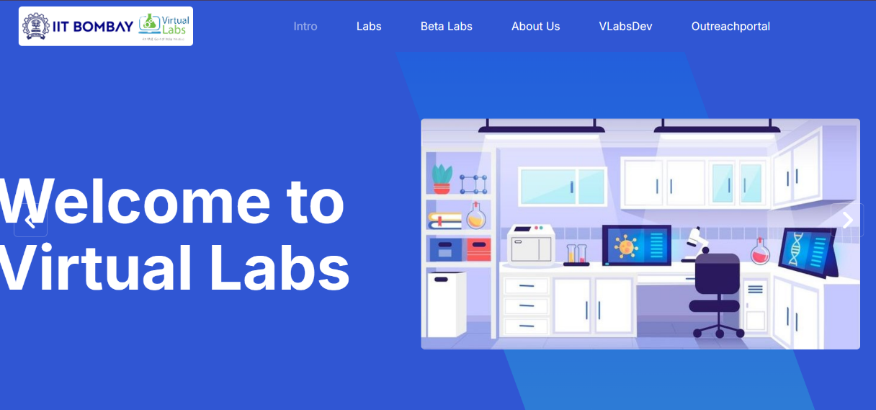India’s Atal Tinkering Labs: Introduced in schools to promote innovation, these labs combine physical and virtual resources to engage students in STEM education (Shyam Diwakar, 2016). <https://iitb.vlabs.co.in/index.html>
* Kenya’s Digital Science Education: This program equips rural schools with low-cost tablets and virtual lab software, significantly improving science education outcomes (UNESCO, 2017). <https://lms.kec.ac.ke/#frontpage-cards>

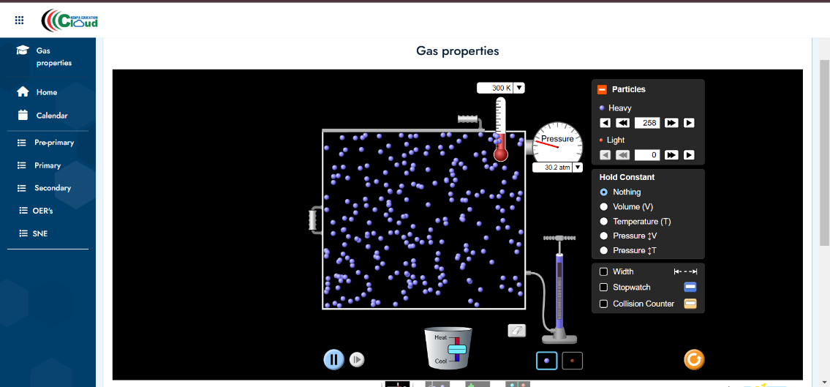

Addressing teacher shortages and the lack of laboratory facilities in rural Sri Lanka requires a multi-faceted approach that combines teacher training, virtual labs, and community partnerships. By leveraging insights from global best practices and local research, it is possible to implement scalable and sustainable solutions to enhance the quality of science education in rural areas.

# References

AbdulRab, H. M. A., 2023. *Teacher Professional Development in the 21st Century.* s.l.:AbdulRab, H. (2023). Teacher Professional.

Aturupane, H., 2011. *Strengthening Science Education in Sri Lanka.* Colombo: South Asia: Human Development Sector, World Bank.

de Silva, D. &. A., 2023. Technology Mediated Education in Sri Lanka: Expectations, Challenges and Strategies. *Journal of Economics & Management Research*, 22 May, pp. 1-7.

Ministry of Education, 2013. *MAHINDODAYA TECHNICAL LABORATORY.* s.l.:s.n.

Ministry of Education, 2021. *2021 Annual Report English,* Colombo: moe.gov.lk.

Ministry of Education, 2021. *Annual Performance Report. Colombo: Government of Sri Lanka.* Colombo: s.n.

Ministry of Education, 2022. *Annual Performance Report- 2021.* Battaramulla: Ministry of Education.

NATIONAL EDUCATION COMMISSION, 2016. *STUDY ON THE PROFESSIONAL.* First Published ed. NUGEGODA: National Education Commission.

NATIONAL INSTITUE OF EDUCATION SRI LANKA, 2022. *SAARC JOURNAL OF EDUCATIONAL RESEARCH.* Maharagama: National Institute of Education.

Nawastheen, F. M., 2019. *EDUCATIONAL AND CURRICULUM CHANGES IN SRI LANKA: IN LIGHT OF LITERATURE,* s.l.: s.n.

Shyam Diwakar, D. K. R. S., 2016. *Complementing Education via Virtual Labs: Implementation and Deployment of Remote Laboratories and Usage Analysis in South Indian Villages,* s.l.: International Journal of Online Engineering (iJOE) 12(03).

Simms, V., 2016. *Mathematical mindsets: unleashing students’ potential through creative math, inspiring messages and innovative teaching.* [Online]   
Available at: https://www.tandfonline.com/doi/full/10.1080/14794802.2016.1237374  
[Accessed 15 11 2024].

UNESCO, 2017. *Education for Sustainable Development Goals.* France: United Nations Educational, Scientific and Cultural Organization.